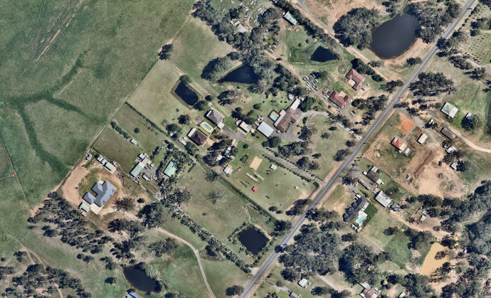

Liverpool City Council is exhibiting Liverpool Local Environmental Plan 2008 (Amendment 89) and invites members of the public to provide feedback.

What is the Liverpool Local Environmental Plan?
The LEP contains zoning and planning controls which guide development for most of the local government area. Some of the LEP controls include the types of development permitted on a particular site, including the floor space and height to which a development can be constructed.

What changes are proposed?
Draft Amendment 89 seeks to insert an enabling clause to allow a recreation facility (outdoor) as an additional permitted use with consent at 25 Dwyer Road, Bringelly. This amendment will not change the existing R5 Large Lot Residential zoning that applies to the site.
The purpose of this amendment is to allow for the ongoing operation of the Burns Outdoor Obstacle Training facility on the site.

How can I make a submission?
Written submissions are to be addressed to the CEO and can be sent to Locked Bag 7064,Liverpool BC NSW 1871; or lcc@liverpool.nsw.gov.au. Submissions are to be received by 5pm Wednesday 10 February 2021, quoting RZ-9/2020.

Where can I get more information?
Visit Council’s website for further information: www.liverpool.nsw.gov.au/public-exhibitions
Enquiries about this proposal can be directed to Luke Oste, Executive Planner, by phone on 8711 7886 or at ostel@liverpool.nsw.gov.au.

What happens next?
Public submissions for Draft Amendment 89 will be considered and reported to a future Council meeting for a final decision.

