STALLHOLDER APPLICATION
– ARTISAN & DESIGN STALLS
EVENT
Date: Saturday, 1 December 2018
Time: 1pm-8pm
Location: Macquarie Mall, Liverpool
Liverpool City Council is seeking Stallholder Applications for the Christmas in the Mall (herein referred to as ‘the Event’) on Saturday, 1 December from 1pm-8pm at Macquarie Mall.
This is an outdoor event.
SECTION 1: INFORMATION FOR APPLICANTS

- Stallholder Criteria
Products for sale must be original items that are locally designed and/or produced. The following items will be accepted for the Art and Design Stalls:
- Locally designed and/or produced fashion and accessories;
- Quality handmade art and handcrafted goods;
- Quality handmade and handcrafted toys, games and hobby items;
- Locally designed and/or produced apparel and homewares;
- Locally manufactured and/or grown produce and packaged foods; and
- Eco-friendly products
As spaces are limited, not all applicants will be successful in obtaining a stall. Council reserves the right to use its discretion to accept or decline any Stallholder Application.
- Stallholder Application Submissions
All Stallholder Applications are due on Friday, 20 July, 2018 5PM. Any late or misdirected applications will not be accepted. All Applications can be emailed to DunnW@liverpool.nsw.gov.au

- Public Liability Insurance
- It is the responsibility of stallholders to hold Public Liability Insurance to the value of $10 million.
- A copy of your Certificate of Currency must be included with this Application Form.
- Applications will NOT be considered if the relevant Certificate of Currency is not attached.

- Stallholder Fee
There are two fee structures, as follows:
- Space only hire – $60 (GST inclusive).
Stallholders must supply their own tables, chairs and marquee and weights. Marquees must be provided and must not exceed 3m x 3m. Council can provide lighting in each stall.
- Council-supplied stall – $120 (GST inclusive)
Council can supply fete stalls (see page 3 for images of fete stalls to be provided), which will include a 2.4x2.4m fete stall with tables and a cover, two chairs and lighting in each stall.

SECTION 2: APPLICANT DETAILS
PRIVACY REQUIREMENTS
Please note that the information provided on this form will be used by Council or its agents to process this application in accordance with Council’s Privacy Management Plan and the Privacy and Personal Information Protection Act 1998. The provision of this information by you to Council is presumed to be voluntary. However, the omission of any information on this form may delay or prevent the processing of your application. For any query regarding the use of information by Council, please contact Council’s Privacy Contact Officer.
STALL TRADING NAME
COMPANY/ORGANISATION
ABN
CONTACT NAME
ADDRESS
EMAIL
PHONE | Landline | Mobile
WEBSITE
SOCIAL MEDIA LINKS | Facebook  Twitter  Instagram
MEDIA PROFILE
(80-100 words)
Please also provide up to 3 photos of your product or stall, for promotional purposes

STALL TYPE | Commercial/Product  Community (registered charity/not-for-profit Organisation)
DESCRIPTION OF ITEMS BEING SOLD

DO YOU REQUIRE A FETE STALL?  See stall diagram and fees on p.3 | Yes  No (If no, you must supply your own equipment, including marquee, which must not exceed 3m x 3m)
DO YOU REQUIRE POWER?  If yes, specify | Yes  No
STALLHOLDER OWNED EQUIPMENT  Note that any electrical equipment needs to have been tagged and tested. | For Risk Management purposes please list all equipment, furniture or display items that you intend to use at the market (ie: display shelving, power cords, etc)  Marquee Tables Chairs  Power Cords Clothing Racks Display shelving  Lighting Other ________________________________________________________  ________________________________________________________  ________________________________________________________

STALL HIRE FEES
There are two fee structures, as follows:

- Space only hire – $60 (GST inclusive).
Stallholders must supply their own tables, chairs and marquee and weights. Marquees must be provided and must not exceed 3m x 3m. Council can provide lighting in each stall.

- Council-supplied stall – $120 (GST inclusive)
Council can supply fete stalls fete stalls (see page 3 for images of fete stalls to be provided), which will include a 2.4x2.4m fete stall with tables and a cover, two chairs, lighting in each stall

Example of the stall

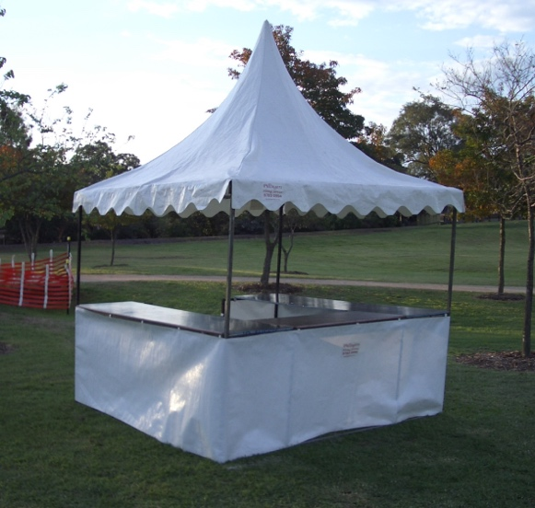
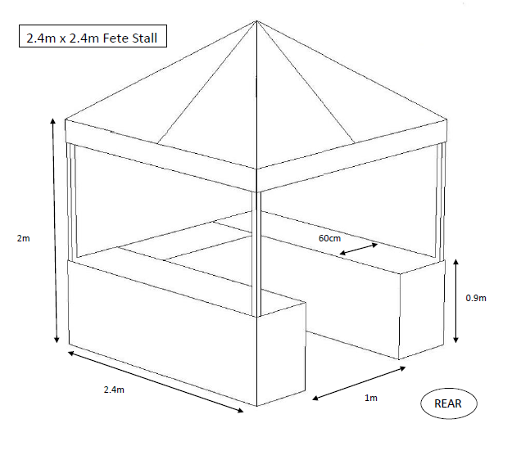

SECTION 3: TERMS AND CONDITIONS

- Stall Information
- Council cannot guarantee site preferences. It is at the discretion of Council to position the stalls in consideration of the overall market design and visitor experience.
- To ensure fair access for businesses to participate in the Event there is a limit of one (1) stall allocation per business/owner.
- The infrastructure is installed prior to stall holder bump-in. Confirmed stallholders will be provided with detailed bump-in/ bump-out information ONE week prior to the Event.
- The Event Coordinator will provide a detailed schedule for stall holder bump-in and bump-out to enable direct car vehicle access to the market stall for delivery and pick-up of stall items. Anyone who does not comply by removing vehicles by the specified time will be warned and may incur penalties issued by Council Rangers.
- Stall spaces will be allocated and marked at the site location. Stalls must fit within the specified space. Encroaching beyond the limits of the allocated site will result in one (1) warning. On the second (2) warning the permission to operate at the Event will be withdrawn.
- Please be aware that photographs of stalls and surrounds will be taken by Council staff and contractors to be used for marketing purposes.
- Please note that music and entertainment is organised as part of this event. Stallholders must not amplify music or spruik using a microphone during the Event.

- Public Liability Insurance

- It is the responsibility of stallholders to hold Public Liability Insurance to the value of $10 million.
- A copy of your Certificate of Currency must be included with this Application Form.
- Applications will NOT be considered if the relevant Certificate of Currency is not attached.

- Stallholder Roles & Responsibilities

- All stallholders are responsible for their own staff, equipment, supplies and materials.
- All electrical equipment and leads must have been inspected and tagged by a licensed electrical contractor, with an expiry date clearly labelled. Leads that have surpassed the expiry date are not to be used, and no electrical leads are to be placed on the ground. If stallholders do not comply or conform to these regulations, permission for to operate at the Event will be withdrawn.
- At the conclusion of the Event, a site inspection will be carried out by the Event Coordinator. It is the stallholder’s responsibility to remove all materials and rubbish from their site by the end of the Event. All stallholders will need to bring their own garbage bags and take their rubbish with them.

- Stallholder Confirmation

The stallholder’s participation in the Event is confirmed upon payment of the stall hire fee.

- Cancellations

- If a confirmed stallholder cancels more than two (2) weeks before the Event date, they will receive a full refund of the stall hire fee.
- If a stallholder cancels within two (2) weeks of the Event date, they will forfeit the stall hire fee.
- Stallholders participate in outdoor events at their own risk. If the Event is cancelled due to inclement weather, stallholders are not eligible for a refund of the stall hire fee.
- If the Event is cancelled by Council for any reason that is not related to inclement weather, stallholders will be entitled to a full refund of the stall hire fee.

- Waste Minimisation & Avoidance

Council is committed to reducing the impact of the Event on our natural environment. This event is guided by the Liverpool City Council Sustainable Event Management Policy

Use the following as a guide to minimise your waste at the Event:
- Avoid Waste
- Reduce unnecessary packaging
- Limit giving out plastic carry-bags. We recommend using paper or reusable bags instead.
- Reduce Waste
- Recycle Waste
Council offers Event patrons and stallholders recycling facilities for certain items. The following items can be recycled in the yellow lid bins provided:
  - Glass bottles and jars
  - Aluminium, steel and aerosol cans
  - Milk and juice cartons
  - Cardboard
  - Paper or cardboard ‘coffee cups’
  - Plastic containers
  - Paper that is not soiled with food, oil or any other material.

All other material, including waxed cardboard, plastic wrapping, food, organic waste, and plastic utensils are NOT recyclable at the Event. These MUST be placed in the general waste (red lid) bins, or taken with you at the end of the day for appropriate reuse, recycling or disposal.

You should sort all recyclable and non-recyclable items on the day to ensure that all items are recycled correctly and to assist with the clean-up.

- List Of Banned Items

- Weapons of any kind, including, but not limited to:
  - replica guns (including plastic guns, pellet guns, water pistols, capguns)
  - ornamental copies (eg. Ninja swords)
  - knives and swords (including pen knives)
  - martial art supplies (eg. nunchuks)
- Explicit and hardcore t-shirts
- Fake cigarettes
- Fuel type fire lighters (eg. zippo)
- Playing cards (nude or lurid)
- Pressure pack stink gas
- Drug related goods (including cocaine kits, bongs, etc)
- Stink bombs
- Water bombs
- Silly string
- Fireworks / crackers
- Laser pointers
- Pop downs / throw downs
- Eight shot caps, strip caps or roll caps
- Any form of shooting projectile toys (eg. bow and arrows).

The Event organisers reserve the right to order the removal of any item from a stall which is considered comparable to any of the banned items. Stallholders selling any items detailed above may be asked to leave the Event.

SECTION 4: AGREEMENT

By completing and returning this Stallholder Application, I (insert name) acknowledge that I have read and agree with the Terms and Conditions set out in this application. I agree to conduct my business in accordance with these guidelines.
Date
Application checklist
 Completed Stallholder Application Form
 Certificate of Currency for Public Liability Insurance
 2 or 3 photos of stall and products sold

Please note that we will issue you with an invoice for the stall hire fee once your application is successful. Cheques are payable to: Liverpool City Council

Please return this application by Friday, 20 July 2018 5PM along with all requested information, as outlined in the Application checklist.

Email all relevant information to Winnie Dunn
DunnW@liverpool.nsw.gov.au

