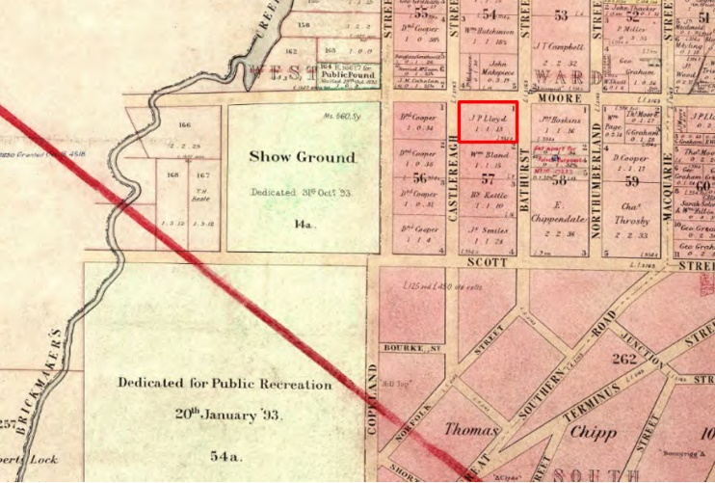

Liverpool City Council is exhibiting a planning proposal request which seeks to amend Schedule 5 of the Liverpool Local Environmental Plan (LEP) 2008 (Amendment 95). Council invites members of the public to view the proposal and provide feedback.

What is the Liverpool Local Environmental Plan?
The LEP contains zoning and planning controls to guide future development. Some of the controls include the types of development permitted on a particular site, including floor space and height to which a development can be constructed.

What changes are proposed?
The planning proposal seeks to amend Schedule 5 of the LEP to add two properties to the heritage items list and remove six existing items from the list.
The properties intended to be added are 122 Atkinson Street, Liverpool (Lot 52 DP 1090837) and 124 Moore Street, Liverpool (Cnr Lot 1 DP 10447).
The six items proposed to be removed are:
Item 4: Two water tanks (RAAF receiving station site and former supply to OTC staff);
Item 5: Former OTC Site Group, including radio receiving station and site of former staff housing;
Item 27: Remnants of former farm homestead (“Pemberton”);
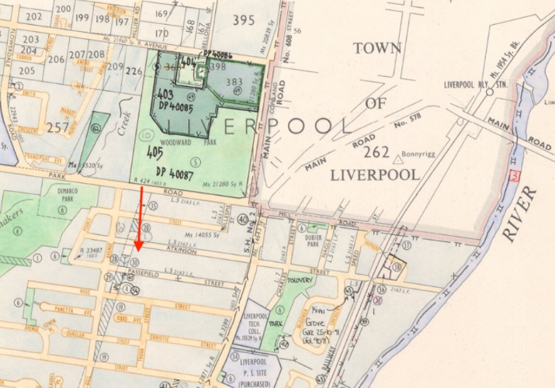

Item 36: Ingleburn village site and lecture hall building (Nissen hut);
Item 57A: Defence National Storage and Distribution Centre; and
Item 59: Remnants of former sandstone cottage (“Benera”).
The items proposed to be removed have been heavily impacted by major developments and / or are no longer subject to the Liverpool Local Environmental Plan 2008. Justification for these changes is contained within the planning proposal report.

How can I make a submission?
Written submissions are to be addressed to the CEO and can be made via:
- NSW Planning Portal;
- Council’s Website; or
- lcc@liverpool.nsw.gov.au
Submissions are to be received by 5pm 10 June 2022, quoting RZ-4/2021.

Where can I get more information?
Please direct enquires about the proposal to Lilyan Abosh, Strategic Planner on 8711 7631 or aboshl@liverpool.nsw.gov.au.

What happens next?
Public submissions for Amendment 95 will be considered and reported to a future Council meeting.

