Liverpool City Council is exhibiting a development application DA-750/2021 which seeks approval for development at 104 Fifteenth Avenue, West Hoxton (Lot 2 DP 1074727). Council invites members of the public to view the application and provide feedback.
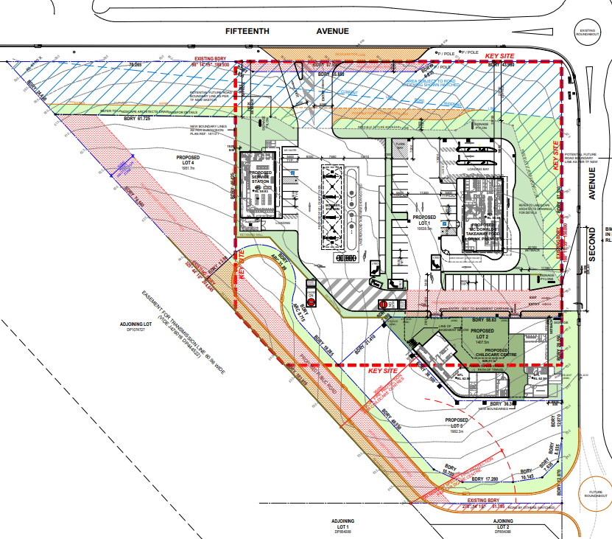

What is a Development Application?
A Development Application is a formal application for development that requires consent under the NSW Environmental Planning and Assessment Act 1979. The application package usually consists of standard application forms, architectural plans and supporting technical reports.

What development is proposed?
The development application DA-750/2021 seeks approval for demolition of the existing structures and construction of a service station and convenience store, take away food and drinks premises, child care centre, signage and Torrens title subdivision of the land.
The proposed development is identified as Integrated Development, requiring an approval from the NSW Rural Fire Service under the Rural Fires Act 1997.

How can I make a submission?
Written submissions for the development application can be made via:
- lcc@liverpool.nsw.gov.au
Submissions are to be received by 5pm 7 August 2022, quoting DA-750/2021.

Where can I get more information?
The development application and plans may be inspected online at Council’s ePlanning page.
Otherwise, please direct enquires about the development application to Kevin Kim, Senior Development Assessment Planner on 8711 7896 or kimk@liverpool.nsw.gov.au.

What happens next?
Public submissions will be considered before Council makes any decision on the application. Council will notify any submitters on the outcome of the application.

