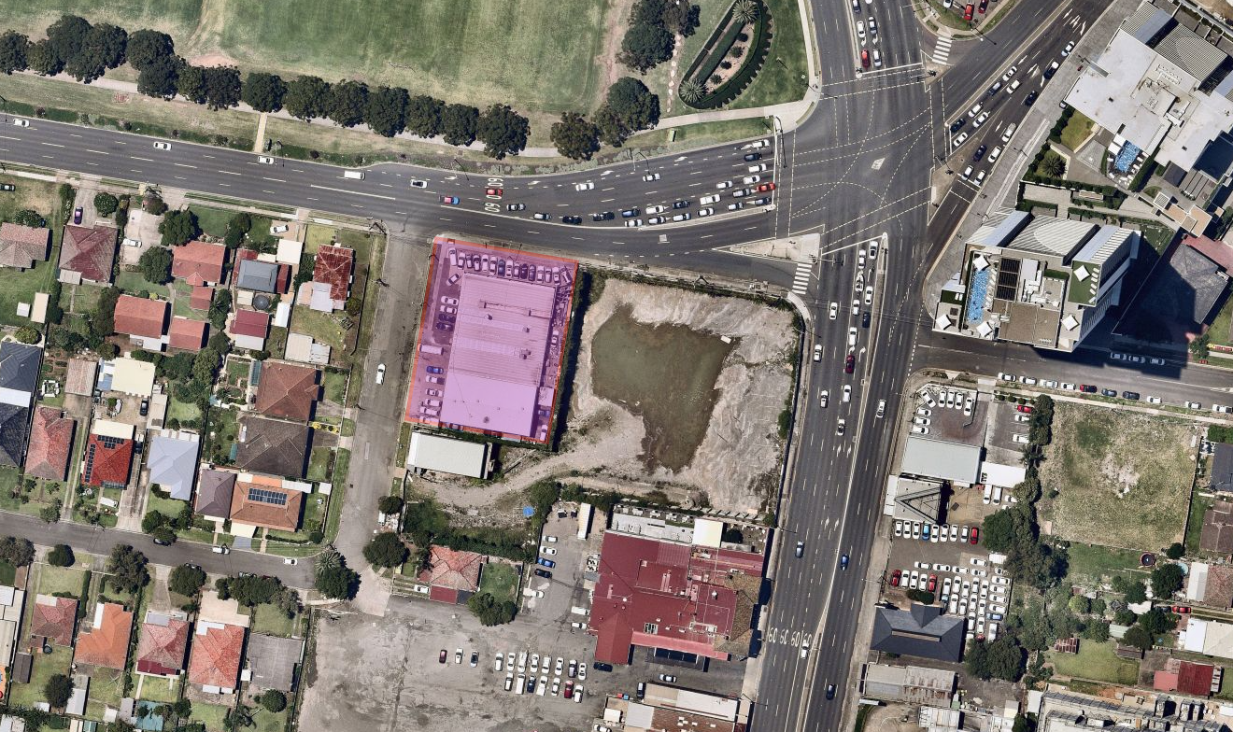
Liverpool City Council is exhibiting Liverpool Local Environmental Plan 2008 (Amendment 79) and invites members of the public to provide feedback.

What is the Liverpool Local Environmental Plan?
The LEP contains zoning and planning controls which guide development for most of the local government area. Some of the LEP controls include the types of development permitted on a particular site, including the floor space and height to which a development can be constructed.

What changes are proposed?
Amendment 79 seeks to change to zoning of the site at 8 Hoxton Park Road from B6 Enterprise Corridor to B4 Mixed Use, amend the floor space ratio (FSR) and height of building (HOB) development standards in the LEP, apply Clause 6.4A of the LEP to the site and remove the site from the Key Sites Map.
The amendment aims to facilitate the development of 90 dwellings and 790m² of commercial floorspace.

How can I make a submission?
Written submissions are to be addressed to the CEO and can be sent to Locked Bag 7064, Liverpool BC NSW 1871; or lcc@liverpool.nsw.gov.au. Submissions are to be received by 5pm Wednesday 17 March 2021, quoting RZ-2/2018.

Where can I get more information?
Visit Council’s website for further information: www.liverpool.nsw.gov.au/public-exhibitions
Enquiries about this proposal can be directed to Cameron Jewell, Programme Lead Liverpool Collaboration Area:
by phone: 8711 7862
by email: jewellc@liverpool.nsw.gov.au

What happens next?
Public submissions on Amendment 79 will be considered and reported to a future Council meeting for a final decision.

