Expression of Interest

Liverpool Pop Up Project

Northumberland Street Arcade - Shop 8

Liverpool City Council

Contents
1. Introduction
2. Call for Expressions of Interest
3. Project Brief
4. Selection Process and EOI Checklist
5. Registration Form
6. Terms and Conditions

Contact
Liz Young
A/Small Business Officer
business@liverpool.nsw.gov.au
02 8711 7575
- INTRODUCTION

  - Liverpool City Council

Liverpool was originally inhabited by the Darug and Gandangara tribes. The clan group around Liverpool was the Cabrogal, named after the Cohbra (or Cahbra) grubs it harvested at the banks of the Georges River, especially near Cabramatta Creek. Liverpool was settled in 1810 by Governor Lachlan Macquarie and is Australia's fourth oldest town behind Sydney, Parramatta and Hobart. Furthermore, Liverpool was the first free-planned settlement in Australia.

Liverpool’s population is over 210,000 and is expected to reach 241,000 by 2021. The Liverpool Local Government Area (LGA) is incredibly diverse, consisting of semi-rural and suburban areas as well as an expanding and lively city centre where major commercial activity exists. In addition, Liverpool is a culturally diverse LGA. It is home to over 140 language groups with 40% of its population born overseas.

Liverpool is Sydney’s third CBD and will be home to the Western Sydney International Nancy Bird-Walton Airport. Liverpool is rapidly growing to become one of the biggest cities in Australia. In line with this growth, Liverpool City Council has undertaken steps to transform the city into a more desirable place to live, work and visit.

  - City Centre Activation

Our Home, Liverpool 2027 Community Strategic Plan sets Council’s vision to create a vibrant and robust city, which is the thriving economic and cultural hub of South Western Sydney. Council has implemented several strategies which are aimed at revitalising the city centre and developing key economic, cultural, and recreational and entertainment precincts.

The Liverpool Pop Up project encourages the activation of the southern end of the CBD at the Northumberland Street Arcade. The intention is to transform vacant shops in the arcade into a creative retail and innovation hub.

1.3 Support for start-ups and small businesses

Council values the contribution small businesses make to the local economy and employment. Key to Council’s Economic Development Strategy is to support start-ups, entrepreneurs and small businesses. The Liverpool Pop Up project will provide an opportunity to trial business concepts and operations in a low risk environment. Successful applicants will be provided business advisory support prior and during their tenancy.

- CALL FOR EXPRESSIONS OF INTEREST

Council is seeking Expressions of Interest (EOI) from start-ups, social enterprises, community groups or artists to set up a temporary retail business. The successful applicant(s) will have the opportunity to test their business concept(s) for a period of six (6) months.

There is one available shopfront - please refer to the Appendix 2 for the shop specifications.

Submissions must address all questions in the application form and include all attachments requested.

Submissions close on Friday, 26 April 2019 at 5pm.

- PROJECT BRIEF

  - Project scope

The Northumberland Street Arcade (Appendix 1) forms part of a chain of arcades that enable pedestrians to cross the CBD whilst enjoying an eclectic mix of retail, hospitality and professional services.

The Liverpool Pop Up project aims to complement the existing businesses by activating the Northumberland Street end of the arcade and creating a hub of artisan and innovative shop. The available shop 8 is equipped with a kitchenette and has approval for use as general retail. See Appendix 2 for the shopfront layout.

The aim of this project is to develop a vibrant and interesting destination that attracts visitors to the area. The shopfronts will provide visitors with a memorable retail experience both in terms of the unique products/services on offer and how customers are engaged.

Potential Pop Up concepts could include:

- Studio or gallery which has artworks for purchase
- Hybrid businesses that combines two or more products/services, for example a bookshop and hand-made artisan products or a tea shop (packaged) and florist
- Artist co-op selling a range of products from local artists and engaging customers through sharing the stories of the makers
- Made to fit upcycled clothing store

If you are unsure whether your proposal is within the scope please contact Liz Young, A/Small Business Officer at business@liverpool.nsw.gov.au or on 8711 7575.

  - Business support

To ensure tenants are well supported throughout the process there are a number of support mechanisms in place. If you require assistance to complete the EOI please refer to Appendix 3.

The successful tenant will have to access complimentary business advisory services prior to and during their tenancy. Support services will be provided by business advisory organisations that aim to assist successful tenants to refine their business plans, financial, marketing and operational strategies.

3.3 Community Engagement (optional)

In line with Council’s Community Strategic Plan, Council can connect tenants with community groups and/or community initiatives. The aim of this is to create greater connections and generate greater opportunities within the community. This can be in the form of offering work experience to locals, providing workshops to local schools or community groups, contributing to a local programme or initiative (please note, certain checks are required if individuals are school aged).

3.4 Licence Agreement

Successful applicants will enter into a Licence Agreement with Council. The Agreement will be proposed for a six (6) month period with the possibility to extend for an additional six (6) months.

Rent will be paid at a peppercorn rate of one dollar ($1) per month. The successful applicant will be responsible for the cost of utilities at a rate of $50 per month. A bond of $200 (EFT, cash or bank cheque accepted) is required prior to the commencement of the lease.

3.5 Technical Considerations

3.5.1 Fixtures & Fittings

The shop fitout is at the successful applicant’s own costs. The successful applicant is given the flexibility to fit out the shop to their creative requirements however the fixtures must be removable and the space left in a “make good” condition. Examples of these fixtures and fittings could be:

- Multiple shelving units that are made up of vertical and angled perspex and solid shelves
- Lockable glass cabinets
- Counter
- Fitting room
- Numerous Display Hooks

3.5.2 Trading Hours

Pop Ups are able to trade six (6) days a week, Monday to Saturday between 8am – 10pm.

The core trading hours which the shopfronts are required to be open are Monday to Friday, 10am–3pm.

3.6 Key Dates

Please refer to the timeframes below for this EOI application round. The Pop Up is expected to be operational by mid May 2019.

Please note, applications can be submitted after this date though will not be considered until the next EOI application round.

1 April 2019 Expressions of Interest opens

19 April 2019 Closing date for all submissions due by 5pm

26 April 2019 Successful submission announced

1 May 2019 Successful applicant provided access to commence shop fitout and setup (subject to Agreement being signed)

Mid May 2019 Pop Up to be operational

- SELECTION PROCESS

A Council Selection Panel will review and evaluate all EOIs, and will decide the successful submission.

Submissions must be sent in a high resolution format (JPEG, PDF) and emailed to:

Liz Young
A/Small Business Officer
business@liverpool.nsw.gov.au
02 8711 7575

Large electronic files are to be sent via a file sharing website. All files should be clearly labelled with the applicant’s name.

  - Selection Criteria

Submissions should address all questions. Submissions will be evaluated according to, but not limited to, the following criteria related to the applicant’s:
- Motivation
- Activation proposal
- Motivation for participating in the program

  - Closing Date

All EOI submissions must be received by Friday, 19 April 2019 by 5pm.

Applications can be submitted after this date but will not be considered until the next EOI application round.

  - Successful Announcement

The selected applicant will be notified by Friday, 26 April 2019 by 5pm.

- APPLICATION FORM: EXPRESSION OF INTEREST
Please complete this Application Form and include it with your EOI submission.

Please ensure you submit your application and submission as a pdf or JPEG.

Application Form
EOI Title: | Liverpool Pop Up
Applicant details
I/We (the Applicant)

(Full Name in BLOCK LETTERS of Individuals, Partners trading in a partnership or Company)
ACN (if a Company): ...... ABN: .................

Address:………………………………………………………………………………………………………
………………………………………………………………………………………………………………….
State: Postcode: ……………….
Telephone: Mobile: ………………….
Email Address:

By signing below I declare on behalf of the Applicant
To the best of my/our knowledge, in submitting the Application, none of the employees, officers or agents of the Applicant have or are likely to have any conflict of interest in relation to matters connected with the Application.
I/We have complied with all mandatory requirement(s) if any, in relation to this Expression of Interest.
I/We agree with the Terms and Conditions specified in Section 6 of this document
Name of Applicant or authorised person(s):………………………………………………………………
…………………………………………………………………………………………………………………
Signature(s): …………………………………………………………………... Date: …../.……/….....…

5.1 Applicant/s Background

Provide a summary of your background and experience and what you think you have to run your own business? (please limit your response to 250 words)

5.2 Motivation

What is your motivation for wanting to start up a business and how will participating in the Liverpool Pop Up Program help?

  - Business or Idea History:

Briefly describe how this business idea started and how long ago.

  - Customer validation

Have you conducted research (surveys, face to face interviews, social media, focus groups etc.) to determine there is a need/desire for your business concept or products? If you have, please tell us more about these results. If you haven’t, please explain why you think it will work.

5.5 Applicants Activation Proposal

Activation is the way you will encourage customers to your shop through interaction and experiences. Please tell us about how you will activate your shop and contribute to the activation of the arcade?

5.6 Marketing

How do you plan to market and connect with your target market to draw them to your Pop Up? Please include your social media channels and extent (if already established).

5.7 Operational Budget

This in generally a short-term budget prepared annually based on realistic estimates of income and expenses associated with running the business. Items usually include, stationary, supplies that you’ve bought that will be used or sold in the shop, advertising, overheads, wages. Money that you have borrowed for this venture would not be included.
Please answer or X to the following:

- Did you prepare an operational budget for this venture
- Did you have assistance to do this

5.8 Shop Layout

Please provide us with an idea of your shop layout and shopfront activation plan. You can do this with drawings or images as separate attachments

5.9 Business support and community engagement

Should you be successful, please indicate whether you would be interested in the below

- Business advisory sessions
- Mentorship
- Participating a community development program
- Sharing the space with another business

Please confirm if there is any other assistance you might require.

5.10 Marketing and media

Please confirm agreement to participate in all related research and media coverage conducted by Liverpool City Council during your Pop Up tenancy, and up to one year thereafter?

- Yes
- No

5.11 Legislative requirements

Please confirm whether you have or will have the following prior to entering into a Lease Agreement with Council:

- An Australian Business Number (ABN)
- Public Liability Insurance with the value of $10 million including plate glass. This insurance is required prior to shop fitout and opening for business

- TERMS AND CONDITIONS

The Terms and Conditions for the Pop Up Shops are as follows:

6.1 Licensing Conditions
The successful applicant and Liverpool City Council will enter into a License Agreement. The key terms and conditions for the Pop Up are as per the below:

- The Agreement is for a period of six (6) months with the possibility to extend for an additional six (6) months
- The cost of the occupation is at a peppercorn rate of one dollar ($1) including GST per month
- The successful applicant will be responsible for payment of water and electricity costs. A standard rate of $50 per month for utilities is payable
- A cash or bank cheque bond of $200 is payable prior to the commencement of the lease
- Minimum trading hours are 5 days per week, Monday to Friday between 10am to 3pm.
- The sites are currently approved for retail uses. Tenant must not vary the “Pop up Shop” usage unless agreed to in writing by Council and/or approved development consent or Complying Development Certificate (CDC)
- The successful applicant must supply their own furniture, tools, and materials. All furniture is required to be removed at the end of the lease. No permanent change to the premises unless agreed in advance with Council
- No structural alterations to the premises
- Premises to be kept clean and presentable at all times
- Premises will be inspected prior to, and at the completion of the lease
- Damages to be rectified prior to the end of the agreement terms
- The successful applicant must vacate at completion of occupancy unless agreed to in writing by Council and
- Council will request the successful applicant to vacate early in the event that the terms and conditions of the lease have been breached

  - Insurance
- The successful applicant is responsible for insurance of their contents and furniture. Council is not responsible for any lost, stolen or damaged contents.
- The successful applicant must keep current an insurance policy covering -
  - Public Liability Insurance to the value of $10 million in relation to any activities undertaken in the Pop Up shops
  - Damage or destruction from any cause to all plate glass in the windows and other portions of the property

  - Reporting and disclosure of information
Council can request progress reports from Business Advisory partners. The information sought after includes: recommendations and advice provided, barriers and key successes identified and an overview of the sustainability of the business.

  - Media & Marketing
The successful applicant must agree to be available for media requests for the duration of the tenancy and up to one year thereafter.

Appendices

Appendix 1 – Site map
Northumberland Arcade highlighted in red

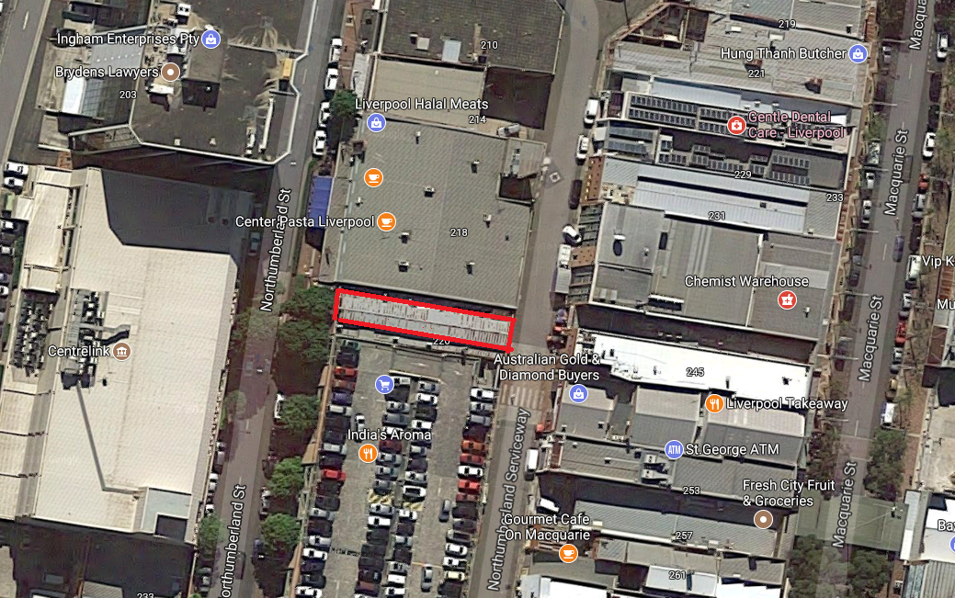
Source: Google

Appendix 2 - Shopfront layouts – Shop 8

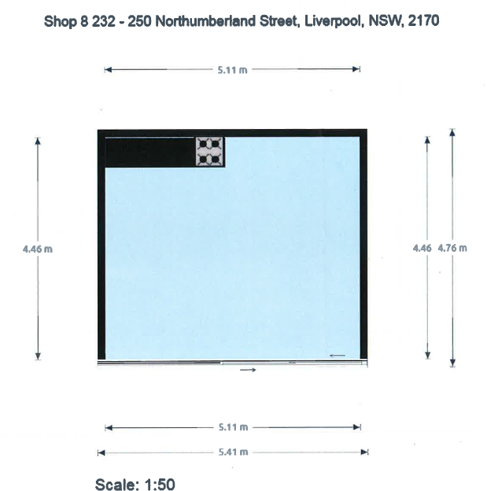

Appendix 3 – Additional Support and Information

Business Connect
If you need help to complete the EOI, Business Connect is a great place to start. Business Connect is a NSW Government program with advisors across the state. The successful applicant for the Pop Up shop will also have access to their experienced staff to help you grow your business. Go to https://business-connect-register.industry.nsw.gov.au to register. On the “Find an advisor page”, you will see there are specialist advisors for creative businesses (Digital, Creative & Finance) or you can find an advisor near you.

Western Sydney Business Centre (WSBC)
WSBC is a not-for-profit organisation and has been providing business advice for nearly 30 years. They will provide a free business advice session. To request a session go to https://wsbusiness.com.au/ to register or email Alex at alex@wsbusiness.com.au.

Liverpool Council
We are here to help and support you through your journey. Feel free to call Liz Young, A/Small Business Officer, on 8711 7575 or email business@liverpool.nsw.gov.au

